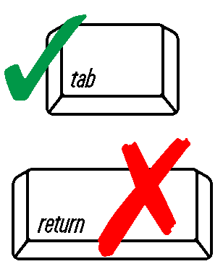
Please Refer to Instruction Pages Before Completing This Form
When filling out forms on the computer, use only the tab key to move your cursor - do not use the return key.

The intent of this form is to assist facilities in submitting reporting requirements to comply with source-specific permit conditions.

Facility Information
1. Date: MM/DD/YYYY |  | 2. Company Name for Permit: |  |  |  |  | 3. Existing State Air Permit Number: |  |  | -
4. Business Mailing Address: |  |  |  | 5. City: |  |  | 6. State: |  | 7. Zip Code: |  | -
8. Plant Location (Street or Highway): |  |  |  | 9. City: |  |  | 10. State: |  | 11. Zip Code: |  | -
12. Facility Contact Person: |  |  |  |  |  | 13. Facility Contact Title:
14. Facility Contact Phone #: |  |  |  | 15. Facility Contact Email:

Reporting Period Information
16. Permit Type: State Minor Operating Permit Conditional Major Operating Permit
Title V Operating Permit (If checked, include RO signature) Construction Permit (Include construction permit designation (i.e., CA, CB):
17. Monitoring Frequency: Daily Weekly Monthly Semi-Annually Annually Other(Please List)
18. Reporting Frequency: Monthly Quarterly Semi-Annually Annually Other(Please List)
19. Reporting Period: (MM/DD/YYYY) through (MM/DD/YYYY)

Report Information
(Please list all conditions, unit ID’s, and Equipment associated with the report)
20. Permit Condition Number: 21. Unit ID(s): 22. Equipment ID(s):

Attach VOC Emissions Report (click here)
20. Permit Condition Number: 21. Unit ID(s): 22. Equipment ID(s):
Attach VOC Emissions Report (click here)

Signatures
I certify under penalty of law that, based on information and belief formed after reasonable inquiry, the statements and information contained in these documents are true, accurate and complete.

Responsible Official Signature*/Authorized Representative  (*Required for Title V sources only) | Title/Position |  | Date

Mail Completed Reporting Form, VOC Emissions % by Weight Emissions Report, and Supporting Documents to:

SC-DHEC-BAQ
Manager, Technical Management Section
2600 Bull Street
Columbia, SC 29201

DHEC 2225 (04/2019)

